

A REPORT

ON

**“CUSTOMER RELATIONSHIP MANAGEMENT”**

**Submitted to**

**Computer Science and Engineering**

**Faculty of Engineering and Technology (Co-Education) In partial fulfillment of the semester project**

### Submitted by

**AATMEEYA PATIL USN: SG20CSE058**

**ABHISHEK S THAKUR USN: SG20CSE005**

**ALOK KUMAR USN: SG20CSE019 DHANRAJ M USN: SG20CSE047**

## Under the Guidance of

## PROFF.SHRAVANKUMAR



**CERTIFICATE**

This is to certify that the project work entitled “**Customer Relationship Management**” is bonafide work carried out by **ALOKKUMAR (SG20CSE019, DHANRAJ M (SG20CSE047), ABHISHEK THAKUR (SG20CSE005) AND AATMEEYA PATIL (SG20CSE058)** in partial fulfillment of **B.Tech 5th Semester in Computer Science and Engineering** of the Faculty of Engineering and Technology (Co-Education), **SHARNBASVA UNIVERSITY, Kalaburgi** during the year 2021-2022. It is certified that, she/he has completed the project satisfactorily.

# Marks Details

|  |  |  |  |  |
| --- | --- | --- | --- | --- |
| **Sl**  **No** | **Name of the Student** | **USN** | **Maximum**  **Marks** | **Marks**  **Obtained** |
| **1** | **AATMEEYA PATIL** | **SG20CSE058** |  |  |
| **2** | **ABHISHEK S THAKUR** | **SG20CSE005** |  |  |
| **3** | **ALOK KUMAR** | **SG20CSE019** |  |  |
| **4** | **DHANRAJ M** | **SG20CSE047** |  |  |

**Guide Chairman Dean**

**Name of the Examiners Signature with Date**

### ACKNOWLEDGEMENT

We express our deep sense of gratitude to our esteemed **“SHARNBASVA UNIVERSITY” KALABURAGI** which has provided us an opportunity to fulfil the most cherished desire to reach our goal.

We also extend our sincere thanks to **Dr. ANILKUMAR BIDVE**, Registrar, Sharnbasva University, for his constant encouragement.

We would like to express our sense of gratitude to our beloved **Dr. SHIVKUMAR JAWALGI** Dean for providing the right academic climate at this university that has made this entire task appreciable.

We are thankful to **Dr.Syeda Asra** HOD, department of Computer Science & Engineering, for giving permission to carry out this project in the university.

We wish to place our grateful thanks to our project guide without his help and guidance; it would not have been possible to complete this project work.

Finally, we express our heartily thanks to all of our staff members of our department, who helped us a lot in the completion of project directly and indirectly within the schedule period.

**AATMEEYA PATIL USN: SG20CSE058**

**ABHISHEK S THAKUR USN: SG20CSE005 ALOK KUMAR USN: SG20CSE019 DHANRAJ M USN: SG20CSE047**

# **ABSTRACT**

In today's dynamic business landscape, customer relationships form the cornerstone of organizational success. This project report delves into the implementation and impact of a Customer Relationship Management (CRM) system aimed at revolutionizing the way our business interacts with and understands our clientele.

Our CRM project focuses on the systematic tracking and analysis of customer interactions, providing a holistic view of their journey with our organization. The report outlines the strategic objectives, methodologies employed, and the transformative outcomes achieved through this CRM initiative.

**Key Highlights:**

1. **Data-Driven Customer Insights:** Our CRM system captures and organizes diverse customer interactions, enabling a nuanced understanding of preferences, concerns, and behaviors. This data-driven approach empowers our team to offer personalized and timely solutions.
2. **Elevated Customer Service:** The CRM implementation has significantly enhanced our customer service capabilities. Real-time access to customer histories facilitates rapid issue resolution, contributing to heightened satisfaction levels and strengthened relationships.
3. **Strategic Customer Retention:** Through meticulous analysis of CRM data, we identify trends, predict customer needs, and deploy targeted retention strategies. This proactive approach aids in reducing churn rates and fostering long-term customer loyalty.
4. **Optimized Sales Processes:** The CRM system has streamlined our sales processes, from lead generation to conversion. By prioritizing high-potential opportunities and tailoring offerings based on customer profiles, we've witnessed notable improvements in conversion rates and overall sales performance.
5. **Performance Metrics and Forecasting:** The report provides an in-depth analysis of key performance indicators (KPIs) derived from CRM data. Additionally, it explores how the system contributes to sales forecasting, enabling informed decision-making and resource allocation.
6. **Operational Efficiency:** The CRM project has not only improved customer-facing processes but has also optimized internal workflows. Seamless integration with other business systems enhances operational efficiency, contributing to a more agile and responsive organization.

**Manner**

**Introduction:**

* + Background and rationale for implementing CRM
  + Objectives of the CRM project
  + Scope and limitations

1. **Literature Review:**
   * Overview of CRM and its importance
   * Key concepts and best practices
   * Relevance to your industry or business sector
2. **Methodology:**
   * Description of the CRM system chosen or developed
   * Implementation process and timeline
   * Data collection methods and tools used
3. **System Overview:**
   * Features and functionalities of the CRM system
   * User interface and accessibility
   * Integration with existing systems
4. **Data Collection and Organization:**
   * Explanation of how customer interactions are captured
   * Data organization and storage mechanisms
   * Security measures implemented
5. **Improved Customer Service:**
   * Examples of personalized interactions enabled by the CRM
   * Case studies showcasing improved response times
   * Feedback mechanisms and continuous improvement

**TABLE OF CONTENT**

|  |  |  |
| --- | --- | --- |
| **SL.NO** | **PARTICULARS** | **PAGE.NO** |
| 1 | Introduction | 6-7 |
| 2 | Objectives | 8 |
| 3 | Language specifications | 9 |
|  | 3.1 HTML,CSS  3.2 Js,PHP,MySQL |  |
| 4 | System specification | 10 |
|  | 4.1 software  specification |  |
|  | 4.2 Hardware  specification |  |
| 5 | Implementation | 11-19 |
| 6 | Results | 20 |
| 7 | Conclusion | 21 |
| 8 | Reference | 22 |

**CHAPTER-1**

**INTRODUCTION**

In the ever-evolving landscape of modern business, cultivating and maintaining meaningful relationships with customers is paramount to sustainable success. Recognizing the pivotal role that customer interactions play in our organizational growth, we embarked on a transformative journey to implement a comprehensive Customer Relationship Management (CRM) system. This project seeks to revolutionize the way we engage with our customers, leveraging cutting-edge technology to enhance service delivery, drive sales growth, and fortify customer retention strategies.

In a world where consumer choices are abundant and loyalty is hard-earned, businesses must continually adapt to meet the evolving needs and expectations of their clientele. Our organization, cognizant of this reality, identified the imperative to consolidate and streamline customer-related data and interactions. The adoption of a robust CRM system emerged as a strategic initiative to not only centralize customer information but also to harness the power of data analytics for informed decision-making.

While this CRM project aspires to yield transformative results, it is essential to acknowledge the scope and limitations inherent in any technological implementation. The scope encompasses the integration of the CRM system across relevant departments, with a focus on customer-facing interactions and sales processes. Limitations may include potential challenges in data migration, user adaptation, and the need for ongoing training.

# **CHAPTERR-2**

# **OBJECTIVES**

# **The implementation of our Customer Relationship Management (CRM) project is guided by a set of strategic objectives aimed at elevating customer satisfaction, optimizing operational efficiency, and driving sustained sales growth. Each objective is intricately linked to the overarching goal of fostering stronger and more profitable relationships with our customers.**

### 1. ****Enhanced Customer Service:****

* **Objective:** To provide a personalized and responsive customer experience by leveraging real-time data on customer preferences and interactions.
* **Rationale:** By centralizing customer data, our aim is to empower our customer service teams with the tools and insights needed to understand and address customer needs promptly and effectively.

### 2. ****Customer Retention Strategies:****

* **Objective:** To reduce churn rates and foster long-term customer loyalty through proactive identification of customer needs and targeted retention initiatives.
* **Rationale:** The CRM system enables us to analyze customer behavior, identify trends, and implement retention strategies that align with individual preferences, thereby increasing overall customer satisfaction and loyalty.

### 3. ****Sales Growth and Optimization:****

* **Objective:** To streamline sales processes, identify high-potential opportunities, and drive revenue growth through data-driven decision-making.
* **Rationale:** By optimizing lead management, analyzing sales performance metrics, and tailoring offerings based on customer insights, our goal is to enhance the efficiency and effectiveness of our sales team, ultimately leading to increased revenue.

### 4. ****Operational Efficiency:****

* **Objective:** To optimize internal workflows, improve team collaboration, and seamlessly integrate CRM functionalities with existing systems.
* **Rationale:** The CRM system is intended to break down silos within the organization, providing a unified platform for various departments to collaborate, share information, and improve overall operational efficiency.

### 5. ****Data-Driven Decision Making:****

* **Objective:** To empower decision-makers with actionable insights derived from CRM data.
* **Rationale:** By harnessing the power of data analytics, our objective is to facilitate informed decision-making at all levels of the organization, ensuring that strategies and initiatives are grounded in real-time customer information.

### 6. ****Continuous Improvement:****

* **Objective:** To establish a culture of continuous improvement based on feedback and analysis of CRM data.
* **Rationale:** The CRM project is not a static initiative but rather a dynamic process that involves ongoing evaluation, adaptation, and improvement. Regular feedback loops and system updates will ensure that the CRM system remains aligned with evolving customer needs and industry trends.

In the subsequent sections, we will delve into the methodologies employed to achieve these objectives and provide a detailed analysis of the outcomes achieved through the CRM project.

# CHAPTER :3

**LANGUAGE SPECIFICATIONS**

1. **CSS (Cascading Style Sheets):** CSS is used to control the visual presentation of the web page. It's responsible for styling elements, such as fonts, colors, spacing, borders, and animations. CSS allows you to make the web page visually appealing and responsive.
2. **JavaScript:** JavaScript is a programming language that adds interactivity and dynamic behavior to the web page. It can be used to create animations, handle user interactions (like clicking buttons), update content without refreshing the page (AJAX), and perform various other client-side tasks.
3. **PHP, which stands for Hypertext Preprocessor, is a widely-used open-source server-side scripting language. It is particularly well-suited for web development and can be embedded into HTML. PHP code is executed on the server, generating dynamic content that is then sent to the client's web browser. Here are some key aspects of PHP:**
4. **HTML (Hypertext Markup Language):** HTML is the standard markup language used to structure the content of web pages. It defines the elements and layout of the page, such as headings, paragraphs, images, links, forms, and more.
5. MySQL is an open-source relational database management system (RDBMS) that is widely used for managing and organizing data. It is known for its reliability, performance, and ease of use, making it a popular choice for web applications and various software projects. MySQL uses the SQL (Structured Query Language) for defining and manipulating data, providing a robust and scalable solution for database management. It supports multiple storage engines, allowing users to optimize their databases based on specific requirements. MySQL is often utilized in conjunction with programming languages like PHP, Python, and Java to build dynamic and data-driven applications. Its open-source nature fosters a large and active community, contributing to its continual development and improvement.

# CHAPTER :4

**SYSTEM SPECIFICATION**

## Software specifications:

Microsoft windows

xampp platfrom

notepad++

## Hardware specifications:

Processor : intel i5 11th generation.

Hard disk : 500GB RAM: 8GB

System type : 64 bit operating system

# CHAPTER :5

**IMPLEMENTATION**

PHP

<?php require_once('../config.php'); ?>

<!DOCTYPE html>

<html lang="en" class="" style="height: auto;">

<?php require_once('inc/header.php') ?>

<body class="layout-fixed layout-footer-fixed text-sm sidebar-mini control-sidebar-slide-open layout-navbar-fixed " data-new-gr-c-s-check-loaded="14.991.0" data-gr-ext-installed="" style="height: auto;">

<div class="wrapper">

<?php require_once('inc/topBarNav.php') ?>

<?php require_once('inc/navigation.php') ?>

<?php $page = isset($_GET['page']) ? $_GET['page'] : 'home'; ?>

<!-- Content Wrapper. Contains page content -->

<div class="content-wrapper" style="min-height: 567.854px;">

<!-- Content Header (Page header) -->

<!-- /.content-header -->

<!-- Main content -->

<section class="content">

<?php if($_settings->chk_flashdata('success')): ?>

<script>

alert_toast("<?php echo $_settings->flashdata('success') ?>",'success')

</script>

<?php endif;?>

<div class="container-fluid">

<?php

if(!file_exists($page.".php") && !is_dir($page)){

include '404.html';

}else{

if(is_dir($page))

include $page.'/index.php';

else

include $page.'.php';

}

?>

</div>

</section>

<!-- /.content -->

<div class="modal fade" id="confirm_modal" role='dialog'>

<div class="modal-dialog modal-md modal-dialog-centered" role="document">

<div class="modal-content">

<div class="modal-header">

<h5 class="modal-title">Confirmation</h5>

</div>

<div class="modal-body">

<div id="delete_content"></div>

</div>

<div class="modal-footer">

<button type="button" class="btn btn-primary" id='confirm' onclick="">Continue</button>

<button type="button" class="btn btn-secondary" data-dismiss="modal">Close</button>

</div>

</div>

</div>

</div>

<div class="modal fade" id="uni_modal" role='dialog'>

<div class="modal-dialog modal-md modal-dialog-centered" role="document">

<div class="modal-content">

<div class="modal-header">

<h5 class="modal-title"></h5>

</div>

<div class="modal-body">

</div>

<div class="modal-footer">

<button type="button" class="btn btn-primary" id='submit' onclick="$('#uni_modal form').submit()">Save</button>

<button type="button" class="btn btn-secondary" data-dismiss="modal">Cancel</button>

</div>

</div>

</div>

</div>

<div class="modal fade" id="uni_modal_right" role='dialog'>

<div class="modal-dialog modal-full-height modal-md" role="document">

<div class="modal-content">

<div class="modal-header">

<h5 class="modal-title"></h5>

<button type="button" class="close" data-dismiss="modal" aria-label="Close">

<span class="fa fa-arrow-right"></span>

</button>

</div>

<div class="modal-body">

</div>

</div>

</div>

</div>

<div class="modal fade" id="viewer_modal" role='dialog'>

<div class="modal-dialog modal-md" role="document">

<div class="modal-content">

<button type="button" class="btn-close" data-dismiss="modal"><span class="fa fa-times"></span></button>

<img src="" alt="">

</div>

</div>

</div>

</div>

<!-- /.content-wrapper -->

<?php require_once('inc/footer.php') ?>

</body>

</html>

**CHAPTER-6**

**RESULT**

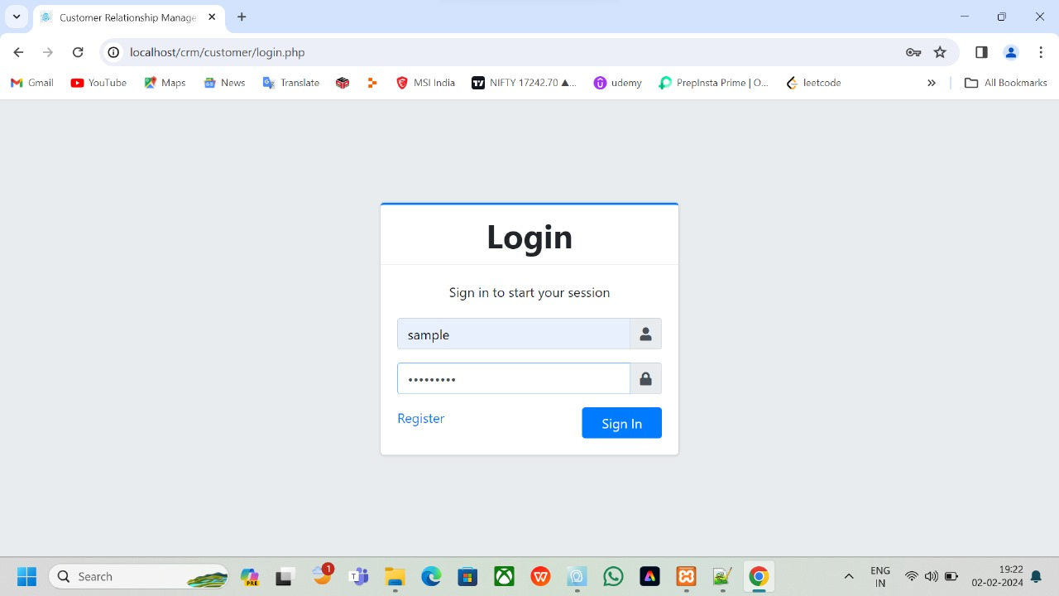

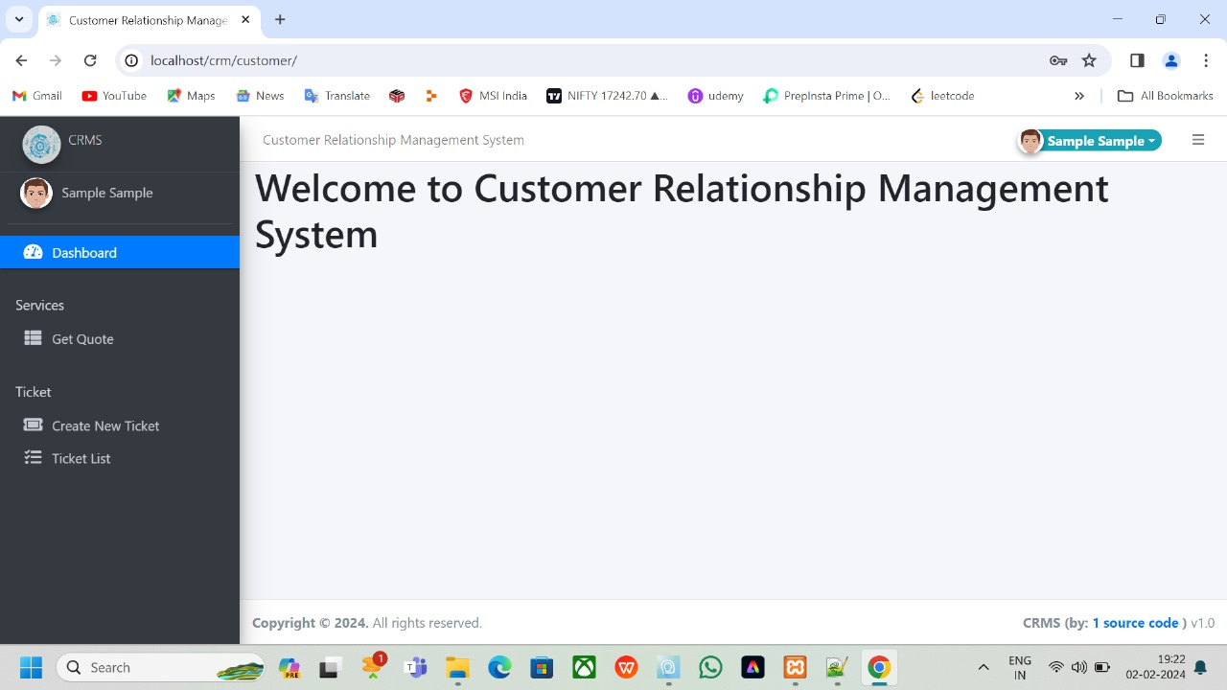

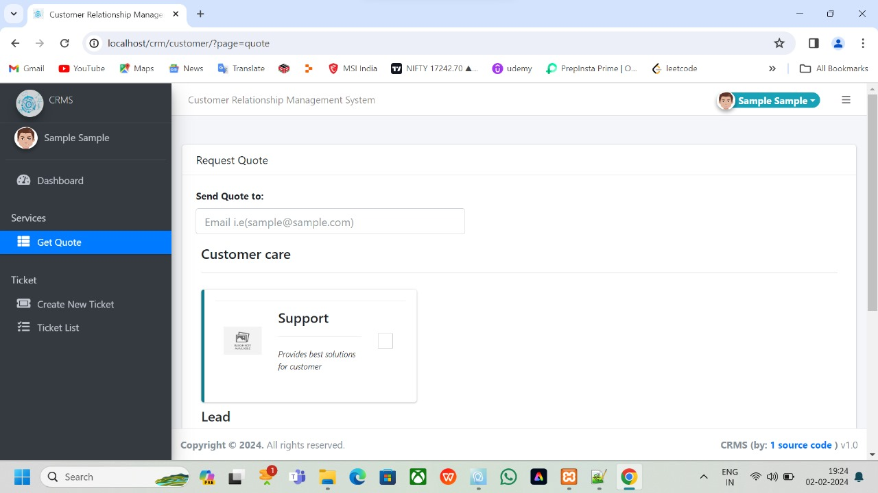

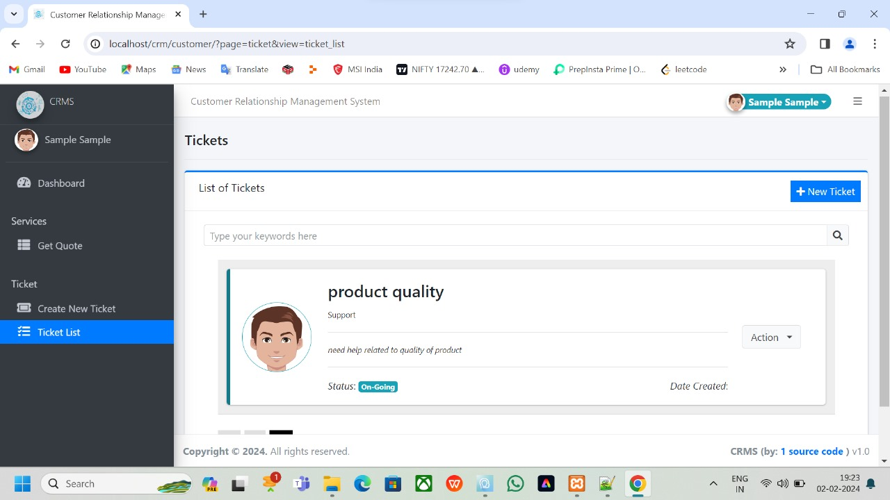

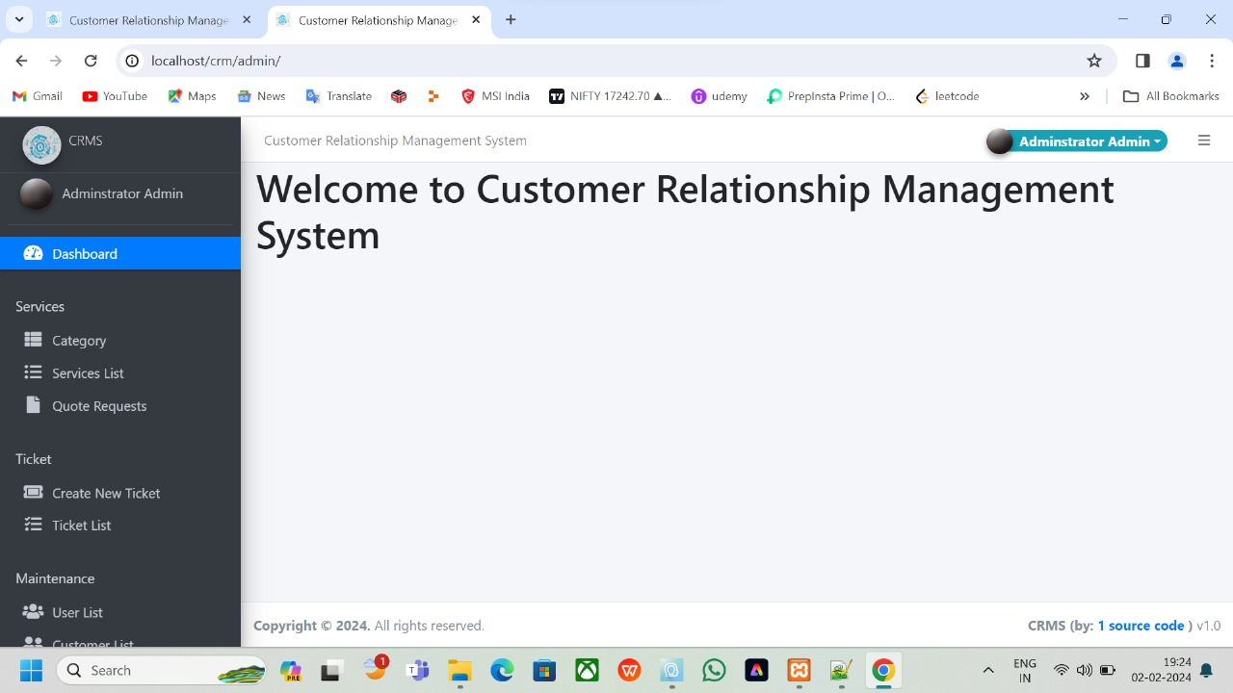

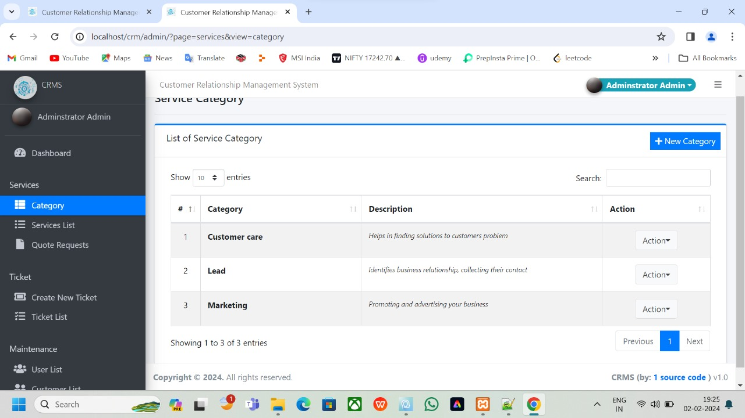

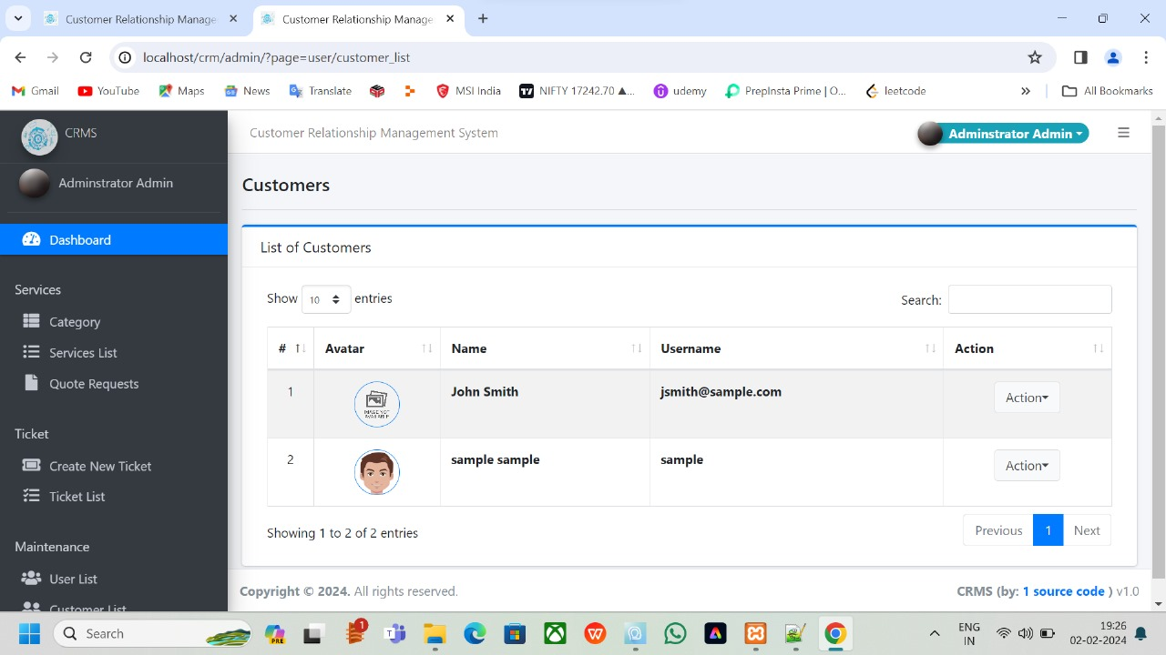

**CHAPTER-7**

**CONCLUSION**

**The implementation of the Customer Relationship Management (CRM) project marks a significant milestone in our ongoing commitment to customer-centricity and organizational growth. Through the meticulous planning, deployment, and utilization of a robust CRM system, we have successfully transformed the way we engage with our customers, streamline internal processes, and drive business success.**

**While the CRM project has yielded significant successes, it is essential to acknowledge the challenges faced during implementation. These challenges, be they in data migration, user adaptation, or system integration, have provided valuable learning opportunities. As we move forward, continuous evaluation and adaptation will be key to addressing evolving customer needs and maximizing the potential of our CRM system.**

**Looking ahead, our commitment to customer relationship management remains unwavering. Future endeavors will focus on refining existing processes, exploring advanced CRM functionalities, and staying attuned to emerging technologies. Ongoing training and development initiatives will ensure that our teams harness the full potential of the CRM system, aligning with our vision of sustained growth and customer satisfaction.**

**In conclusion, the CRM project stands not as a singular achievement but as a foundation for perpetual improvement, innovation, and a steadfast commitment to delivering exceptional customer experiences.**

CHAPTER-8

# REFERENCES

* [**http://www.google.com/**](http://www.google.com/)
* [**http://www.w3schools.com\c\**](http://www.w3schools.com/c/)